**D.SARATH BABU-192311031**

EXP 12: CHANGE HARDWARE COMPATIBILITY OF A VM (EITHER BY CLONE/CREATE NEW ONE) WHICH IS ALREADY CREATED AND CONFIGURED.

**AIM:**

To Change Hardware compatibility of a VM (Either by clone/create new one) which is already created and configured.

**PROCEDURE:**

**STEP 1:**GOTO VM WARE WORKSTATION.

**STEP2:** RIGHT CLICK THE VM AND GOTO THE SETTINGS.

**STEP 3:** ADD HARDWARE WIZARD AND SELECT SCSI AND CLICK NEXT.

**STEP 4:** CREATE NEW VIRTUAL DISK.

**STEP 5:** SELCT THE DISK SIZE AS 2.0. AND SELCT SPLIT VIRTUAL DISK INTOMULTIFILES.

**STEP 6:** GIVE NAME AND CLICK THE FINISH.

**IMPLEMENTATION:**

**STEP 1:GOTO VM WARE WORKSTATION**

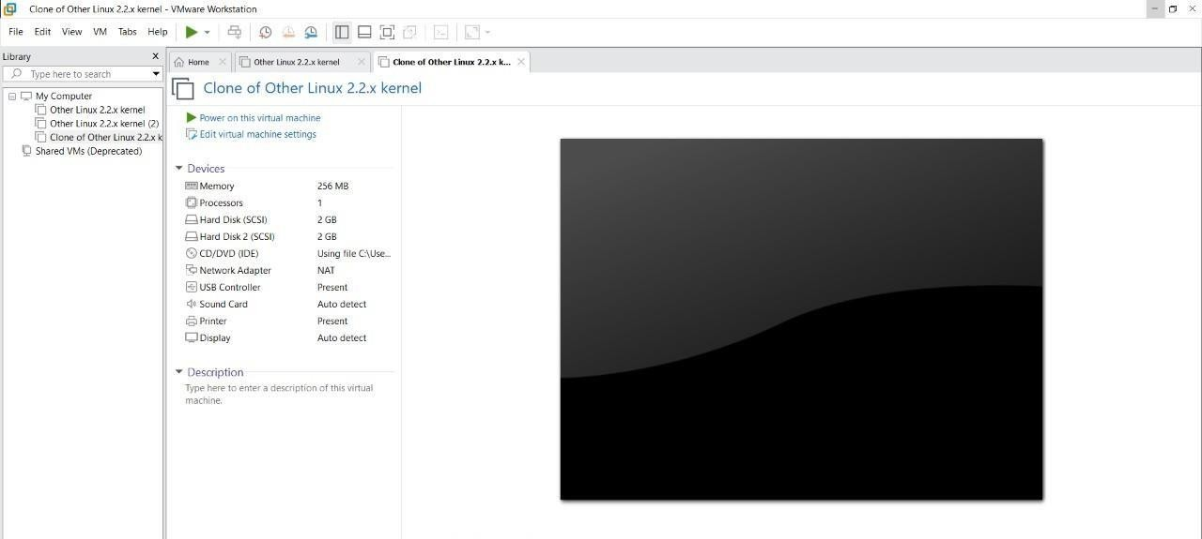

**STEP2: RIGHT CLICK THE VM AND GOTO THE SETTINGS**

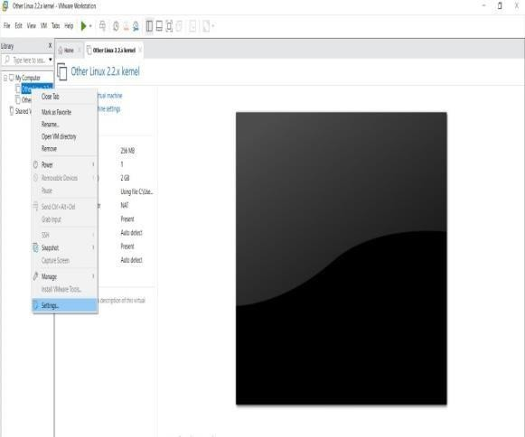

**STEP 3: ADD HARDWARE WIZARD AND SELECT SCSI AND CLICK NEXT**

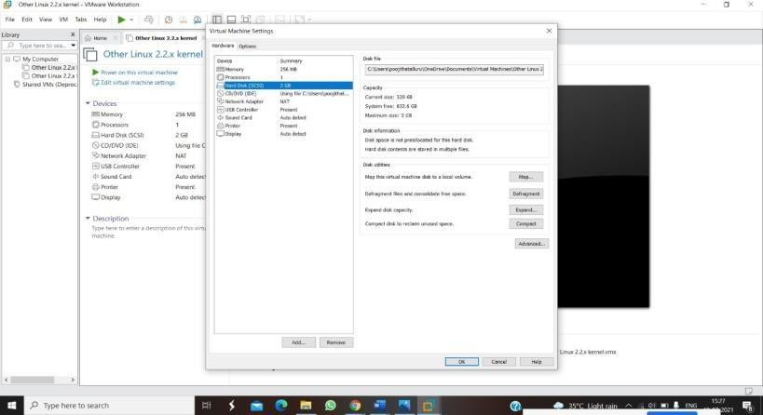

**STEP 4: CREATE NEW VIRTUAL DISK**

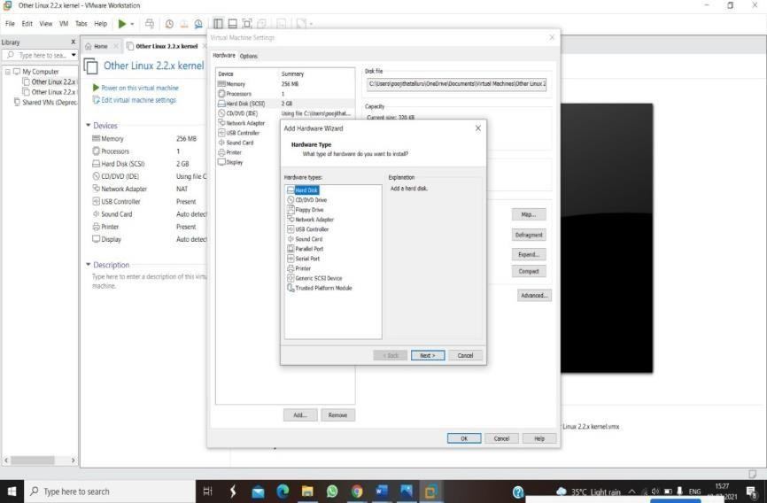

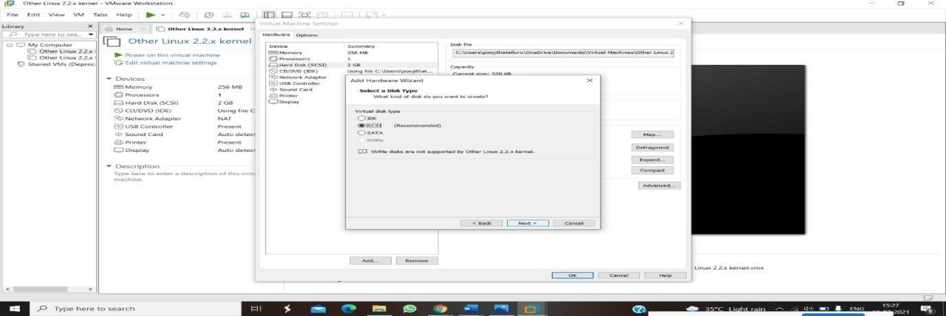

**STEP 5: SELCT THE DISK SIZE AS 2.0. AND SELCT SPLIT VIRTUAL DISK INTOMULTIFILES.**

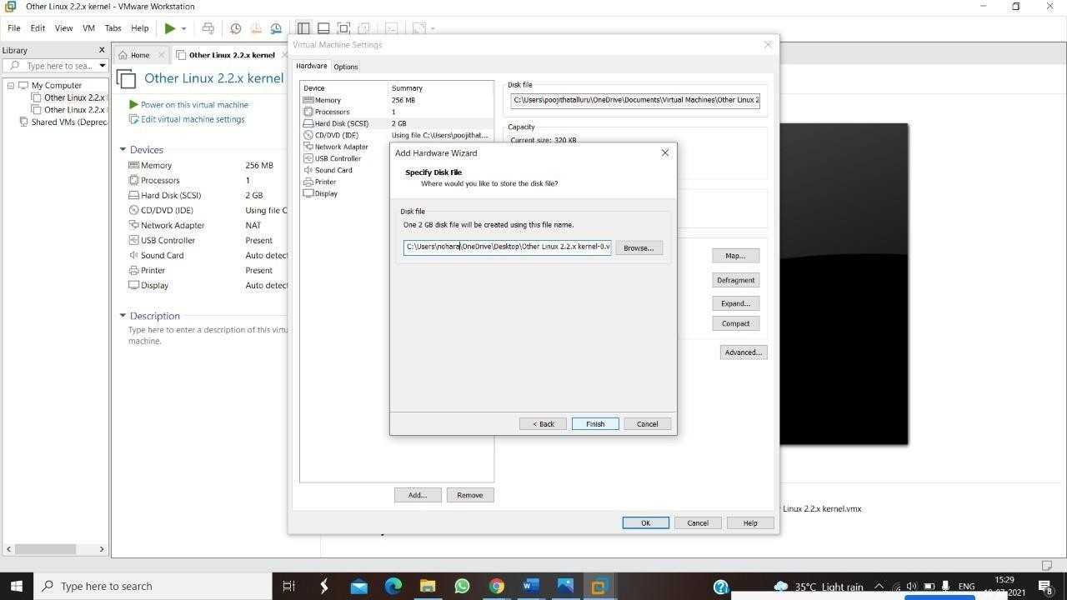

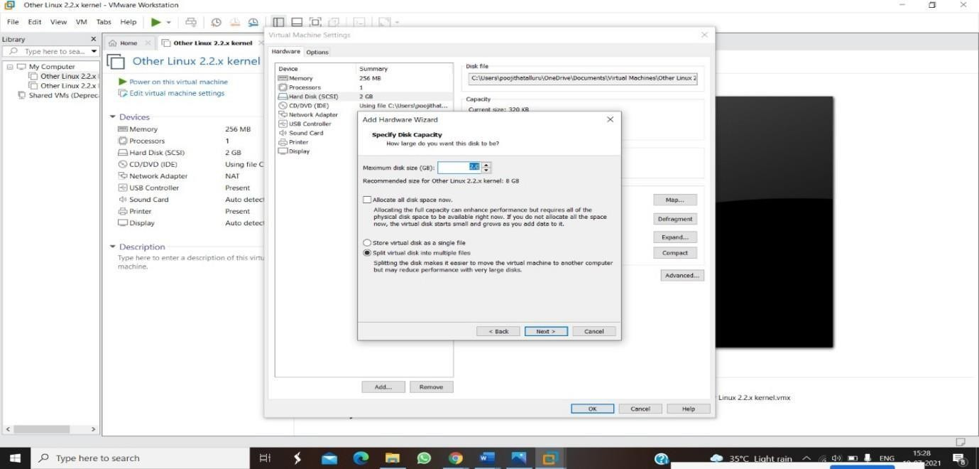

**STEP 6: GIVE NAME AND CLICK THE FINISH**

